Welcome to Nano-Electronics and Computing Research Center (NeCRC). The demand for much higher performance computing machines is never ending. Nano-electronics has a great promise in delivering the ever increasing demand for computational power set by increasing expansion of the information technology and its evolution towards the next wave of change in society, the Virtual Age.
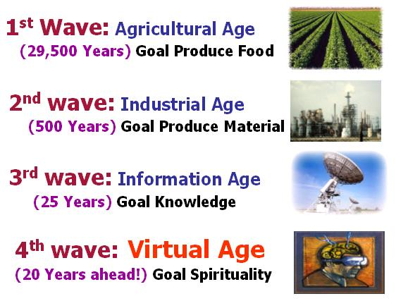
Waves of change in human history

Designing reliable, energy efficient, high performance computing machines in emerging nanotechnologies is our mission at NeCRC. As the technology continues to scale down towards nanometer regimes, there are tremendous research opportunities to address the grand challenges and barriers of scaling. Our research addresses the technology scaling challenges at the circuit and architecture levels of abstraction.
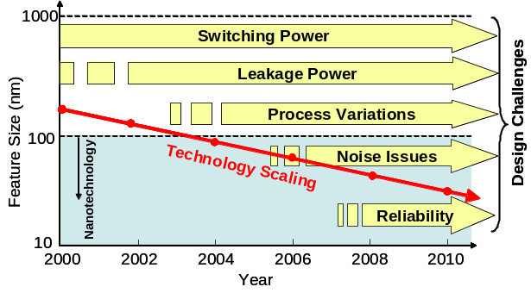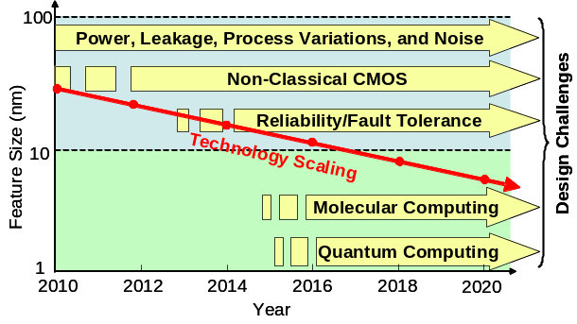
(a) (b)
Research directions at NeCRC (a) short-term and (b) long-term

We always welcome students who are interested in joining our research. Interested students, please contact Prof. Mahmoodi to learn more about current research opportunist to get involved.

